FREQUENCY TABLES
Pearson Edexcel - Thursday 7 June 2018 - Paper 2 (Calculator) Higher Tier
1.
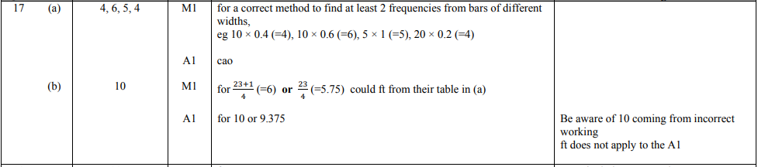
Pearson Edexcel - Thursday 4 June 2015 - Paper 1 (Non-Calculator) Higher Tier
2.
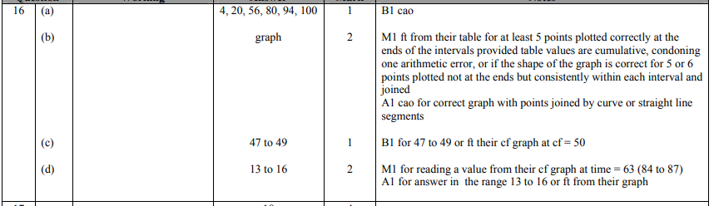
Pearson Edexcel - Monday 8 June 2015 - Paper 2 (Calculator) Higher Tier
3.
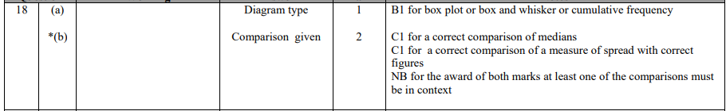
Pearson Edexcel - Monday 8 June 2015 - Paper 2 (Calculator) Higher Tier
4.
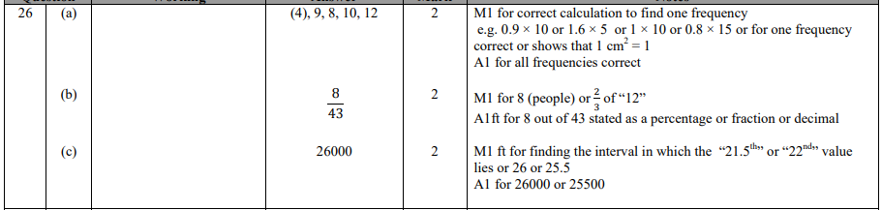
OCR GSCE – Tuesday 5 November 2019 – Paper 6 (Calculator) Higher Tier
5.
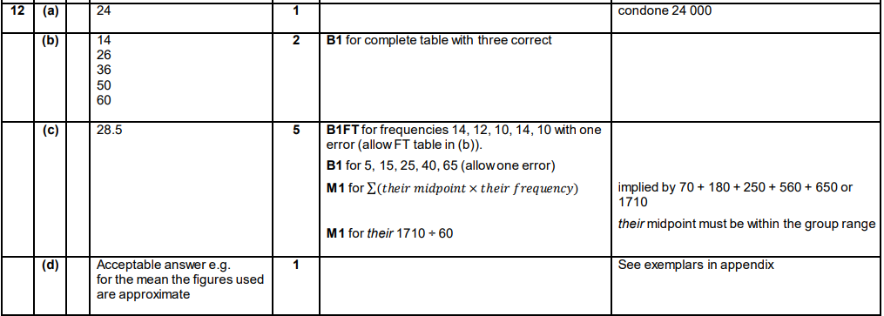
OCR GSCE – Monday 12 November 2018 – Paper 6 (Calculator) Higher Tier
6.
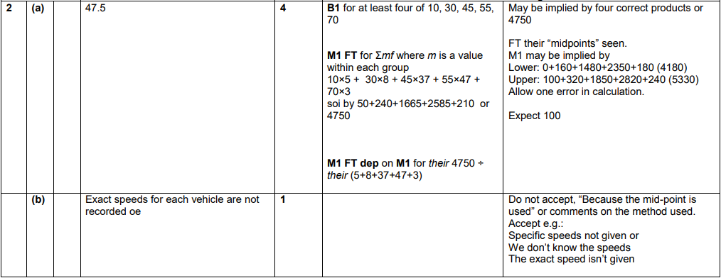

OCR GSCE – Thursday 7 June 2018 – Paper 5 (Non - Calculator) Higher Tier
7.
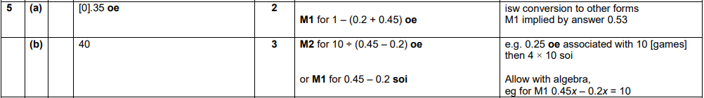
OCR GSCE – Wednesday 8 November 2017 – Paper 6 (Calculator) Higher Tier
8.
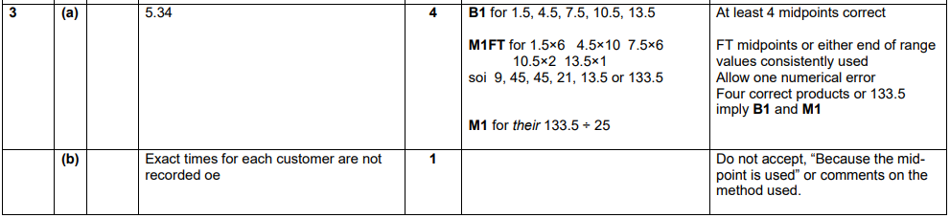
OCR GSCE – Thursday 8 June 2017 – Paper 5 (Non - Calculator) Higher Tier
9.
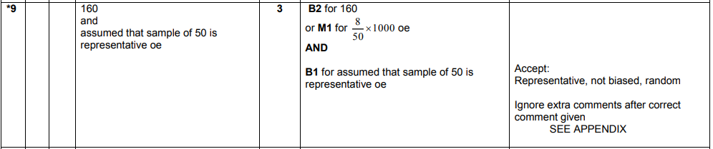
AQA GSCE – Thursday 8 June 2020 – Paper 3 (Calculator) Higher Tier
10.
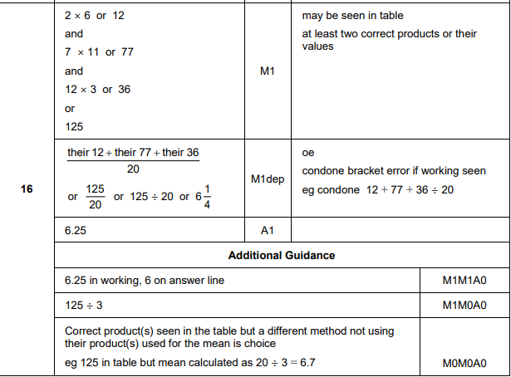

AQA GSCE – Thursday 6 June 2019 – Paper 2 (Calculator) Higher Tier
11.
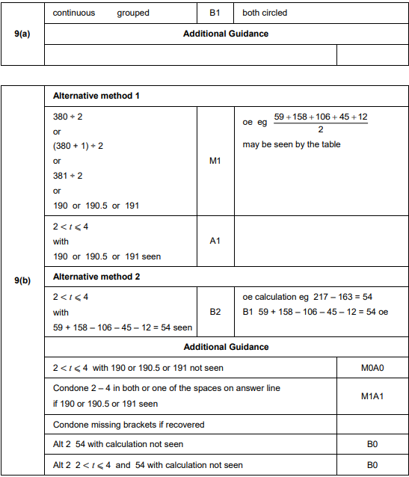
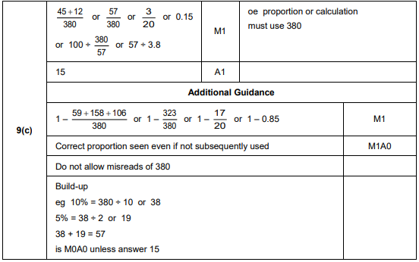
AQA GSCE – Thursday 6 June 2019 – Paper 2 (Calculator) Higher Tier
12.
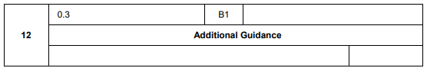
AQA GSCE – Tuesday 11 June 2019 – Paper 3 (Calculator) Higher Tier
13.
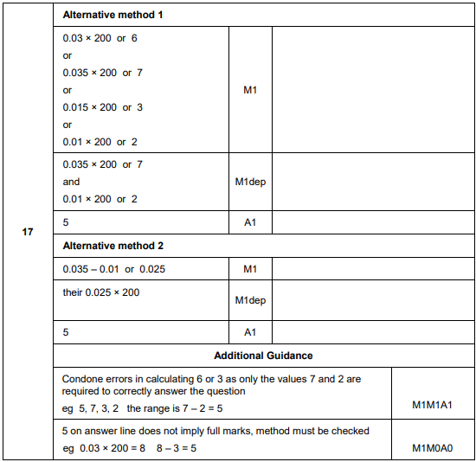
AQA GSCE – Tuesday 6 November 2018 – Paper 1 (Non - Calculator) Higher Tier
14.
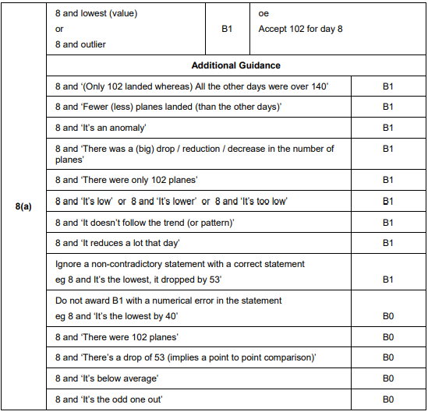
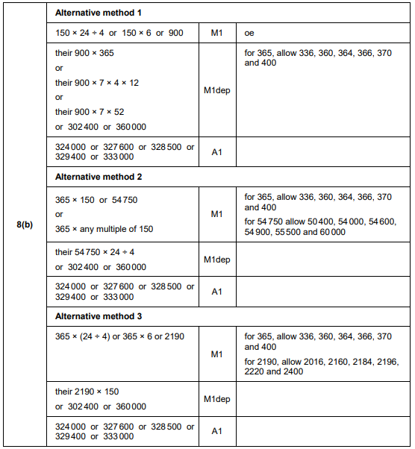
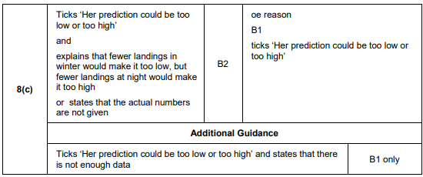
AQA GSCE – Monday 24 May 2018 – Paper 1 (Non - Calculator) Higher Tier
15.
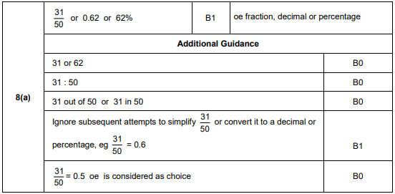
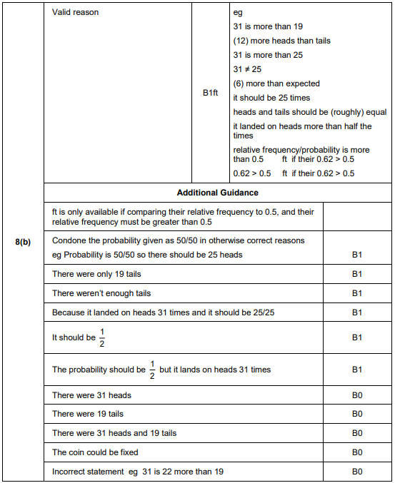
AQA GSCE – Thursday 6 November 2017 – Paper 2 (Calculator) Higher Tier
16.
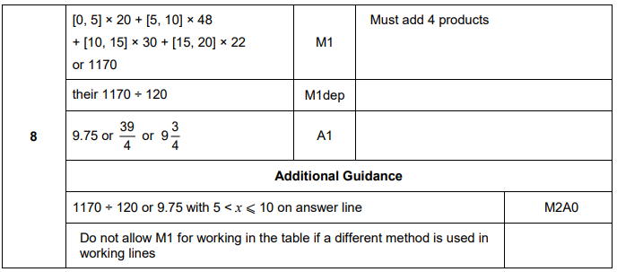
AQA GSCE – Wednesday 8 November 2017 – Paper 3 (Calculator) Higher Tier
17.
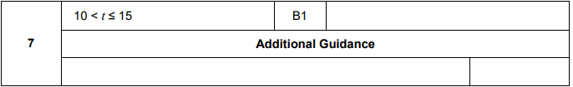
AQA GSCE – Wednesday 25 May 2017 – Paper 1 (Non - Calculator) Higher Tier
18.
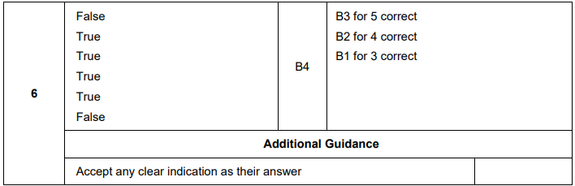
AQA GSCE – Sample Paper 3 (Calculator) Higher Tier
19.
